**SEDIMENTARY ROCKS**

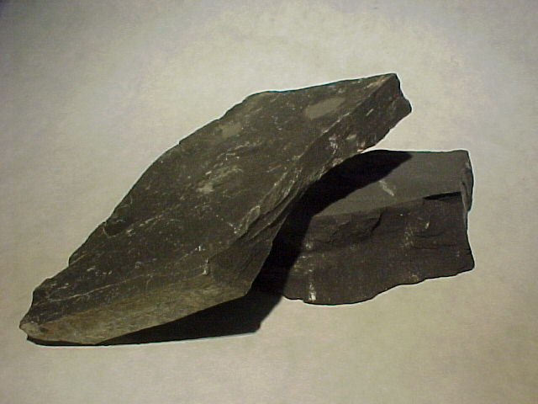 **SHALE 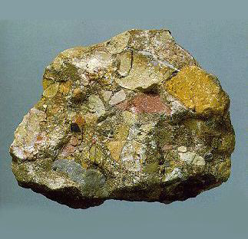 BRECCIA**

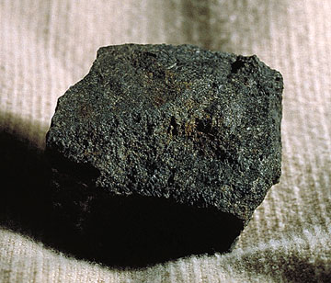 **COAL 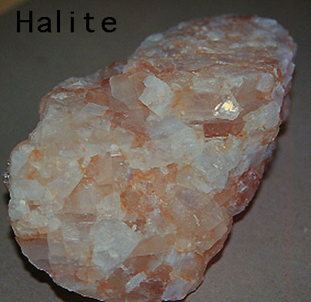 HALITE**

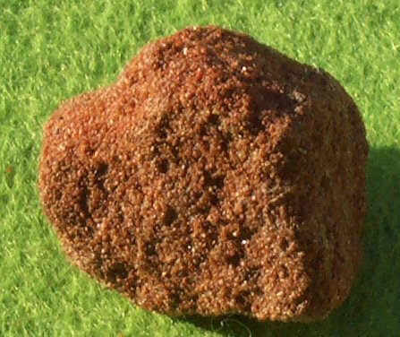 **SANDSTONE 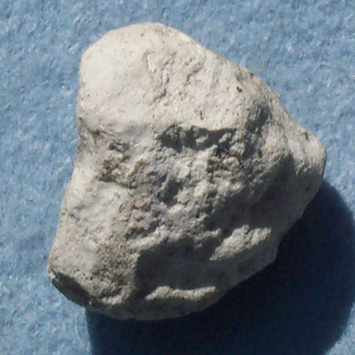 CHALK**

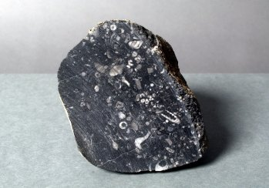 **LIMESTONE 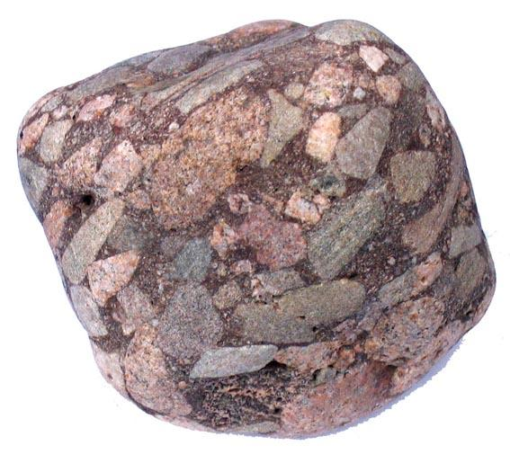 CONGLOMERATE**

**METAMORPHIC ROCKS**

 **HORNFELS**   **MICA SCHIST**

 **SLATE**  **MARBLE**

 **QUARTZITE**  **GRANITE GNEIS**

**[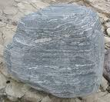](http://www.google.com/imgres?imgurl=http://upload.wikimedia.org/wikipedia/commons/8/88/Migmatite_2005.jpg&imgrefurl=http://commons.wikimedia.org/wiki/File:Migmatite_2005.jpg&usg=__FipD6SWI1NXM2YrvPCbbPfoSzPk=&h=742&w=800&sz=366&hl=en&start=2&zoom=1&itbs=1&tbnid=Em3lXaGY-AOvqM:&tbnh=133&tbnw=143&prev=/images?q=MIGMATITE&hl=en&safe=active&gbv=2&tbs=isch:1) MIGMATITE**

**IGNEOUS ROCKS**

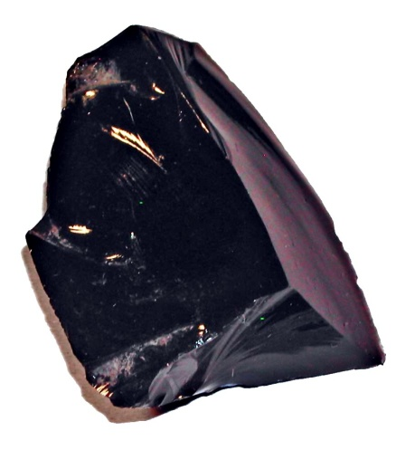 **OBSIDIAN  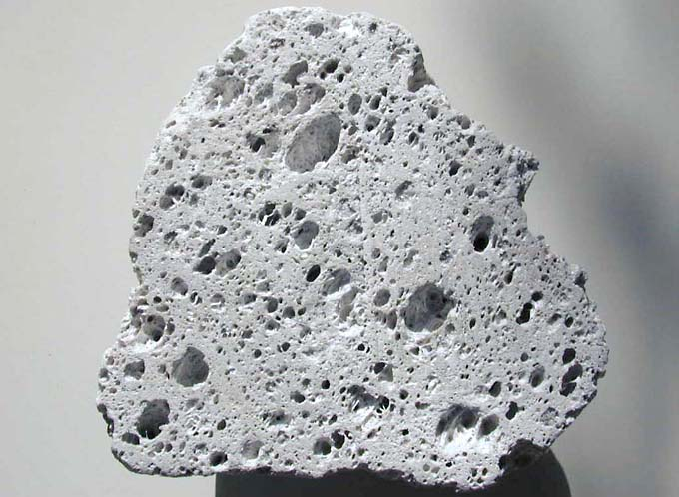 PUMICE**

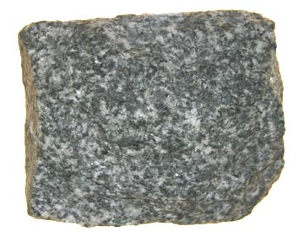 **GABBRO  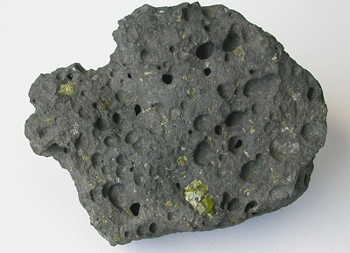 BASALT**

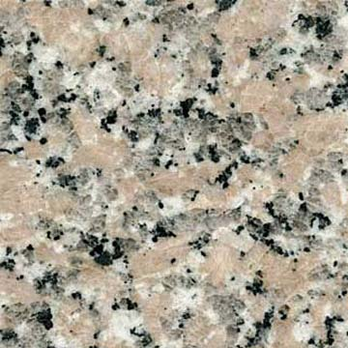 **GRANITE  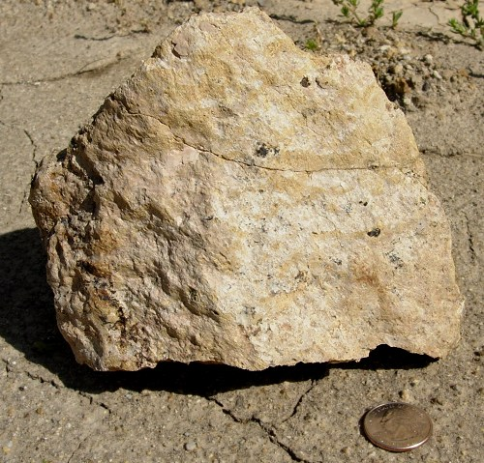 TUFF**

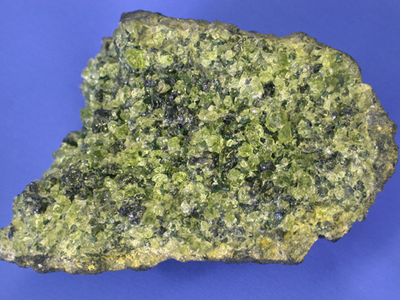 **PERIDOTITE 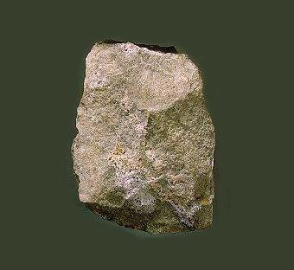 RHYOLITE**